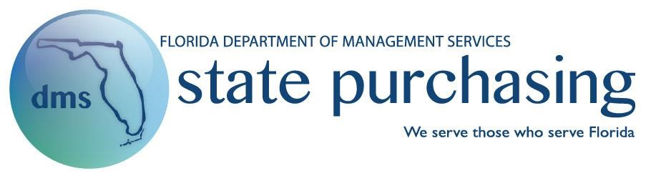

**Information Technology Staff Augmentation Services**

**Contract No. 80101507-SA-15-1**

**Exhibit B**

**Resume Self-Certification Form**

Contractor candidates shall complete this Resume Self-Certification Form. Completed Resume Self-Certification Forms shall be submitted within the Contractor’s response to Customer’s RFQ’s, see Section 1.29 of the Contract.

“I the undersigned do hereby certify, under the penalty of perjury, that information in my resume submitted for consideration of the State of Florida contract position is true, correct, complete, and made in good faith to the best of my knowledge and belief. If an omission, falsification, misstatement, or misrepresentation has been made regarding my education, work ability, experience, employment history, and/or fitness for employment as a contractor, I may be disqualified as a contractor, and the matter will be reported to appropriate agency or law enforcement personnel. I understand that there are civil and/or criminal penalties for misrepresenting pertinent information in connection with contract positions, including, but not limited to, penalties available under Florida Statutes 287.133 or 817.566. I further understand that if I am not a United States citizen, violation cases may be reported to the US Department of Homeland Security for potential deportation.”

“In addition, I the undersigned do hereby consent to the release of my information by employers, educational institutions, law enforcement agencies, and other individuals and organizations to investigators and other authorized agents of Florida for verification and investigation purposes. I understand that any documents submitted to procure a contract(s) with the State of Florida, including resumes, are public records.”

Chaturvedi Uthanoor

______________________________________

Print Full Legal Name of Candidate

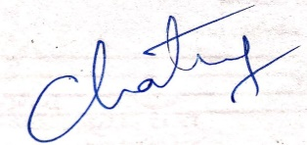 02-22-2019

|  |  |  |
| --- | --- | --- |
| _____________________________________ | ___________________ |  |
| Candidate’s Signature  Texas | Date  41313587 |  |
| _____________________________________ | ____________________ |  |
| Candidate’s Form of Identification Presented | Identification number |  |
| ___________________________ _____ | ___________________________ | _____ |
| Contractor’s Witness Signature One Date | Contractor’s Witness Signature Two | Date |
| ___________________________ | ___________________________ |  |
| Print Name Contractor’s Witness One | Print Name Contractor’s Witness Two |  |

Information Technology Staff Augmentation Services

STC No. 80101507-SA-15-1 Page 1